**Residential Waste Detection and Channeling Application**

**(WASTEASE)**

**Product Capstone**

* **Screenshoot Demo**

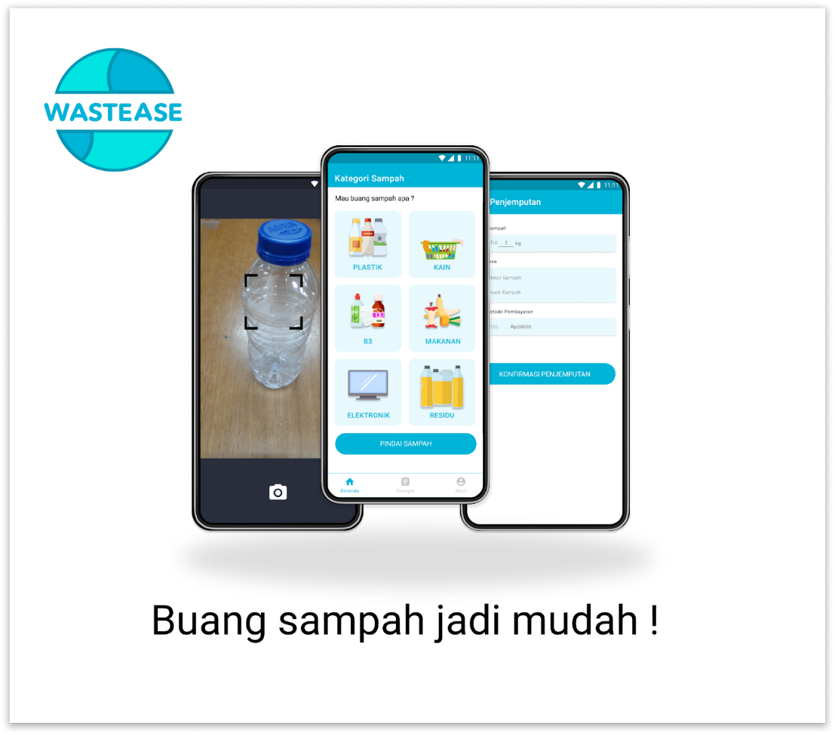

* [[Github Repo](https://github.com/Mfuadshidqi/project_capstone_C22-PC388)]
* [[Figma](https://www.figma.com/file/vcVdvKxThvBa2tdieeYdgC/Capstone-Project-(Waste-Channeling-App)?node-id=0%3A1)]
* [[Presentation Video](https://youtu.be/V9RByn5SDAk)]
* [[Silde Presentatio](https://docs.google.com/presentation/d/11VLyzGRMGZgN8iy11gvzPo0qxqZR90gYnd_efeWkt8k/edit?usp=sharing)]